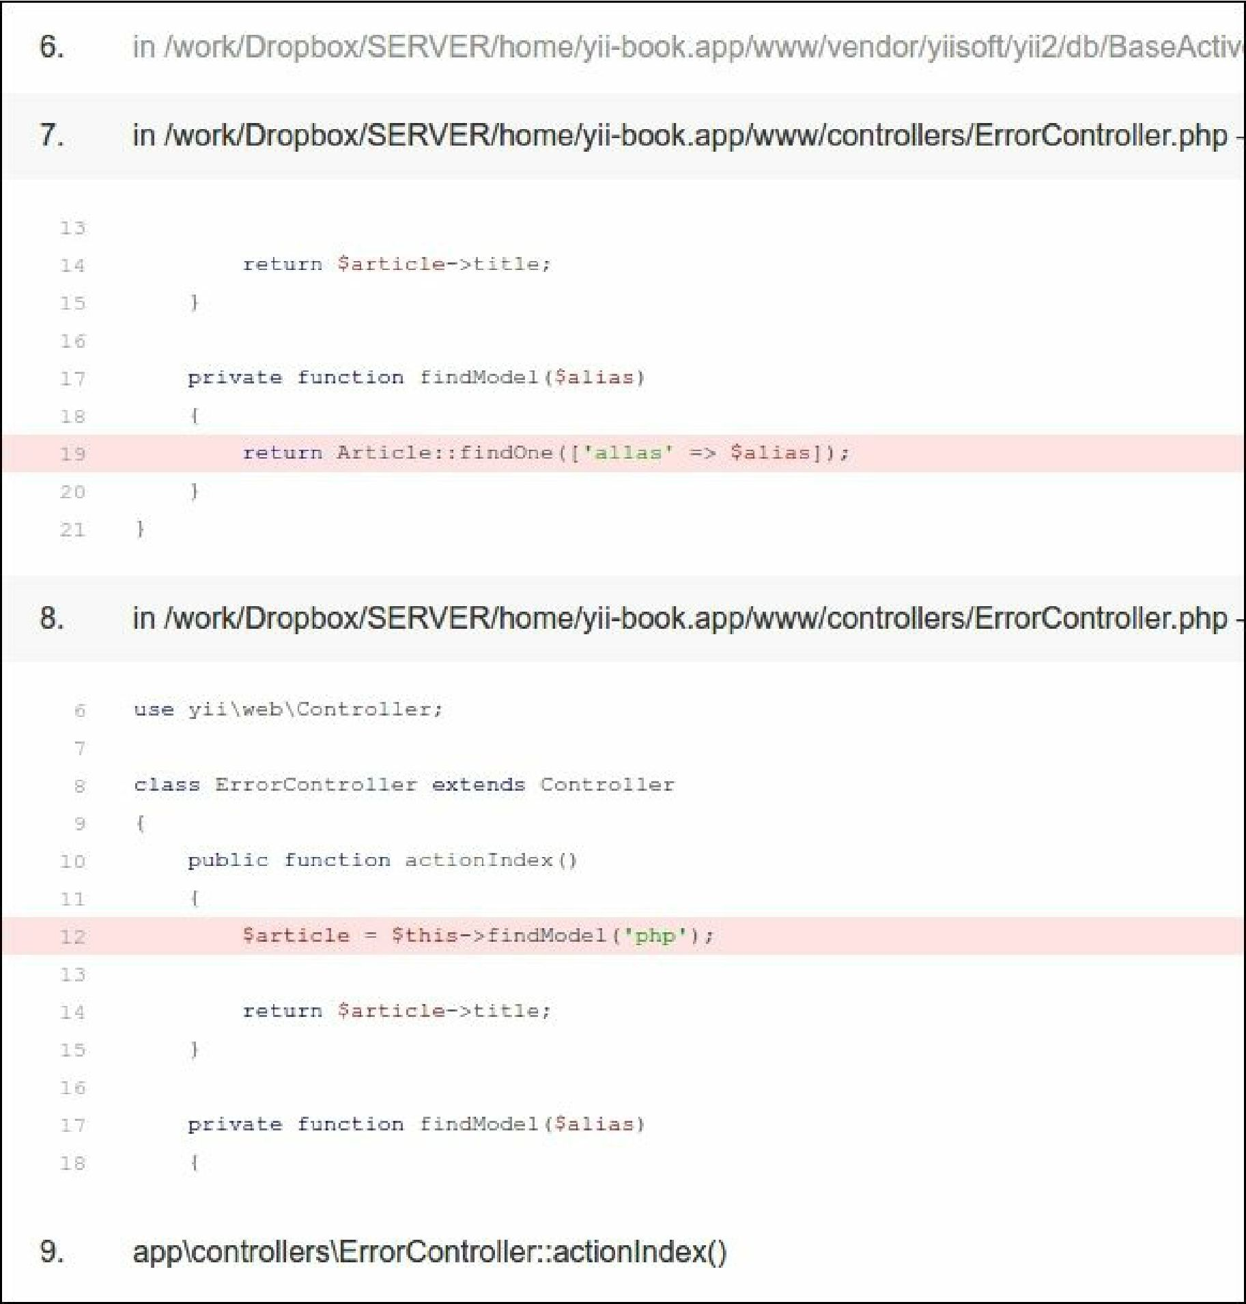

How it works...

From the error message, we know that we have no alias column in the database, but we have used it somewhere in the code. In our case, it is very simple to find it just by searching all the project files, but in a large project, a column can be stored in a variable. Moreover, we have everything to fix an error without leaving the screen where the stack trace is displayed. We just need to read it carefully.